**PCN Community Pop-up Clinic**

Within each practice there are rising numbers of patients registering who are vulnerable, who live on the streets, no constant method of communication and who have a history drugs, trafficking or violence. These patients are often difficult to reach out to, who don’t have the capability of contacting the practice due to day-to-day circumstances. They can be complex patients who often have undiagnosed or untreated health issues. It’s these patients we wanted to reach out to.

In January 2024, the Central Walthamstow Primary Care Network (PCN) established a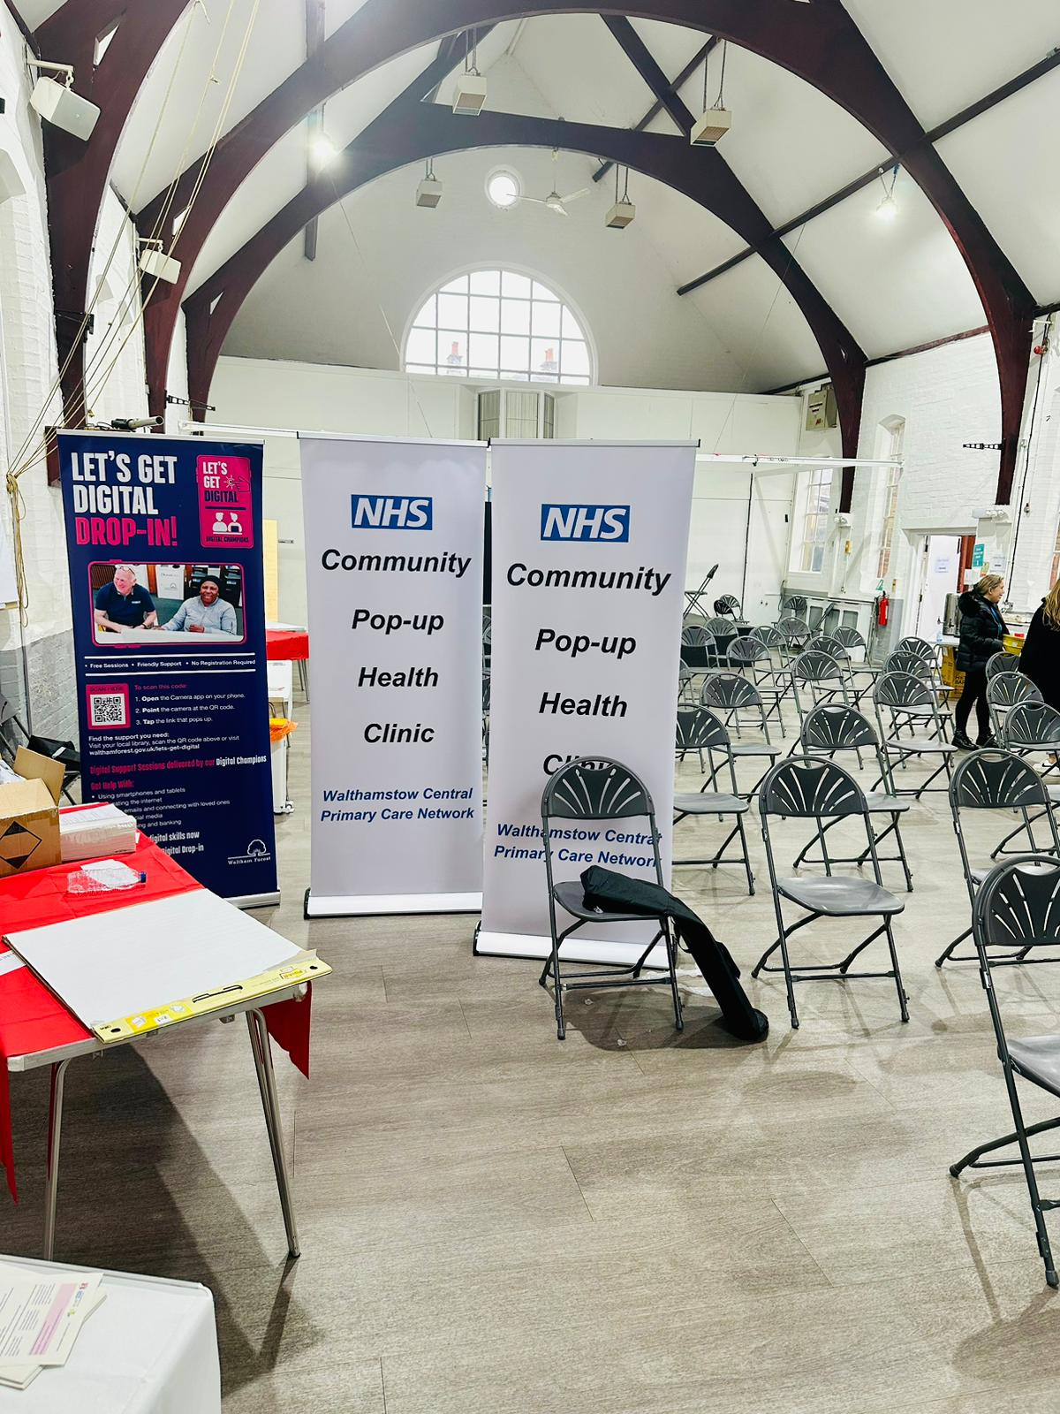 community-based outreach initiative through a pop-up clinic. This initiative aimed to address health inequalities by providing residents with the opportunity to access a variety of community services, including consultations with General Practitioners (GPs), without the need for appointments. The goals of the clinic were twofold: to identify and understand the unmet needs within the community and to address health disparities by improving access to essential healthcare services.

#### **Key Outcomes and Impact**

1. **High Satisfaction Rates**
   * An overwhelming 96% of respondents reported satisfaction with the pop-up clinic, indicating a positive reception and the effectiveness of the services provided.
2. **Strengthening Community Bonds**
   * The event fostered a sense of community, with 80% of attendees expressing their intention to follow up with a service they had engaged with at the clinic. This indicates a strong likelihood of continued utilisation of healthcare services, which is crucial for long-term health outcomes.
3. **Identification of Unmet Needs**
   * The clinic successfully identified significant unmet healthcare needs, with 42% of respondents indicating they would not have sought help from their GP or any other community service for their health issues if the clinic had not been available.
4. **Reduction in Strain on Acute Services**
   * Over 10% of attendees mentioned that, in the absence of the pop-up clinic, they would have sought care from emergency departments (ED) or urgent care services. This highlights the clinic's role in alleviating pressure on acute care facilities by providing accessible primary care and community services.

#### **Community Impact and Future Plans**

The Waltham Forest pop-up clinic has demonstrated a strong commitment to tackling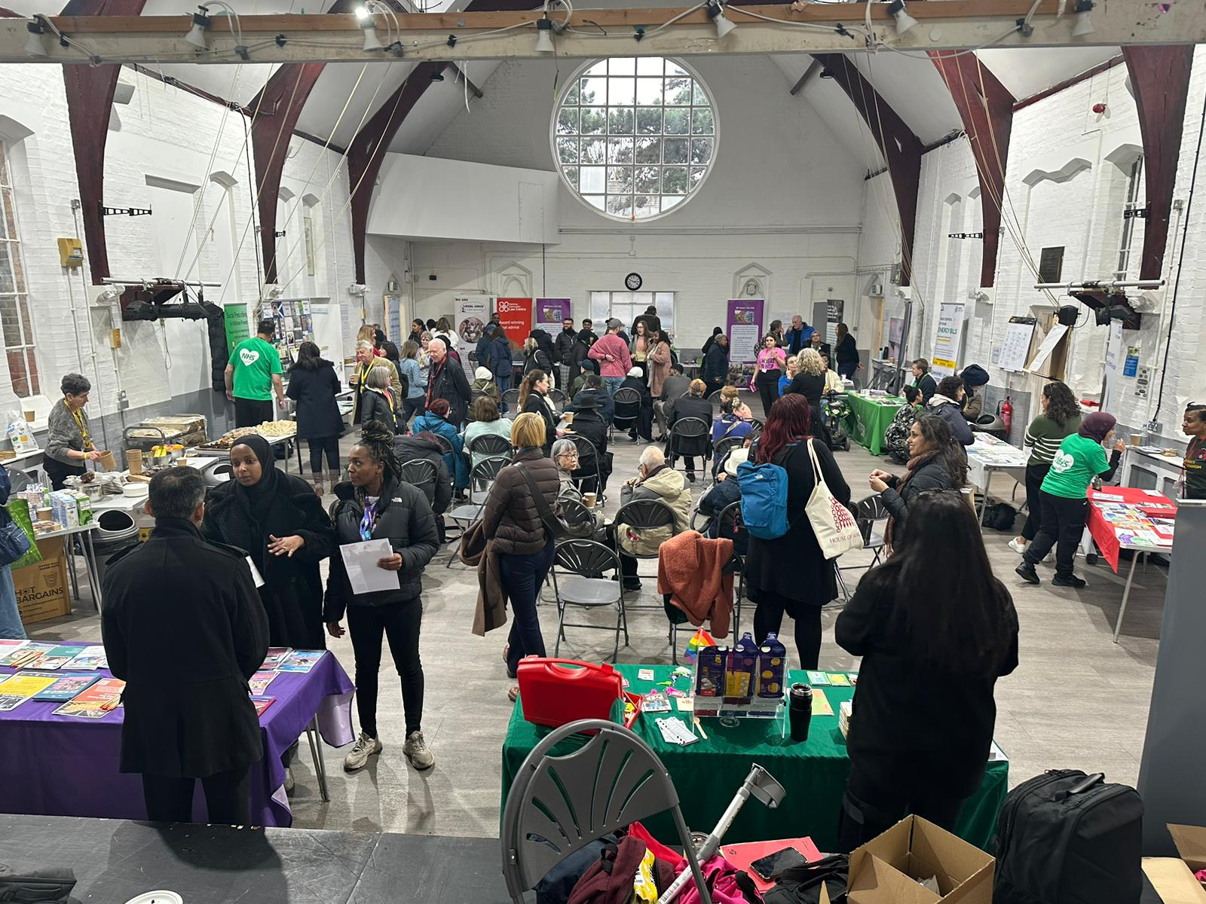 health inequalities and addressing the social determinants of health. By taking healthcare services out of traditional settings and into the community, the clinic has not only met immediate healthcare needs but also laid the groundwork for future outreach initiatives.

The success of the pop-up clinic serves as a catalyst for ongoing and future plans to extend healthcare beyond the confines of traditional general practice. The PCN plans to continue leveraging community-based approaches to deliver high-quality care to vulnerable populations, ensuring that the most in need have access to essential health services.

In conclusion, the Waltham Forest pop-up clinic represents a significant step towards reducing health disparities and improving access to care for vulnerable residents. The overwhelmingly positive response from the community underscores the importance of such initiatives and the critical role they play in fostering a healthier, more equitable society.